




Program Highlights

Learning Journey Guide

Java Track
–

Full

Program at a glance

Learning consisting of
2

Stages

and an Integrated Development Project
:

•

Stage 1-

•

Stage 2

-

Design & Enterprise Development

•

Integrated Development Project
(
IDP
)

•

The complete learning journey is formalized using adult learning principles, where problem solving and
applying the skills gained are given more importance than conceptual learning.

•

Get mentored by SME
s from BU
,
whose motivation and guidance will help you accelerate in the learning
journey.

•

Learner Autonomy is encouraged via Flipped Classroom, where the learning platform offers world class
learning resources, and students would not be constrained by tutelage of an instructor.

•

Through Project
-
Based Learning (PBL), GenCs will go through the entire project phase, embracing Agile
practices

Why do we need this Academy enablement Program?

Academy enablement program engages young talents with a comprehensive learning pathway, giving these
millennials an opportunity to interact with Subject Matter Experts (SME) and understand the corporate environment
and groom themselves even before they join
n us.

Cognizant emphasizes on Learner Autonomy where students take charge of their own learning, with the available
tools and resources. More focus is on “learning” than “teaching”. Get ready to embark your own learning adventure!

Gen
C Program

ICP Java (Direct Stage 2) - v5
(CCM) - Handbook

Foundation & Core Skills - Refresher
Generation Cognizant (GenC)

Know Your Service Line

w Your Service Line – ADM (Application Development and Maintenance)
Service Lines
Service lines can simply be defined as a modern organizational structure strategy for resource planning and allocation for any size of business. Typically, traditional organizational structure models are more vertically aligned -- think of an employee who has several bosses in the hierarchical ladder before being directly under the company’s owner or president. Conversely, service lines follow a more horizontal continuum approach, where the company is strategically segmented into more manageable departments. The service line approach tends to focus more on the requirements of customers, which often results in noticeable increases in the customer satisfaction rate.
What is Application Development?
Application development goes through a process of planning, creating, testing, and deploying an information system, also known as the software development lifecycle. Applications are also often developed to automate some type of internal business process or processes, build a product to address common business challenges, or drive innovation.
What is Application Maintenance?
Application maintenance is the continuous updating, analyzing, modifying, and re-evaluating of your existing software applications. Application maintenance must be an ongoing task to ensure your applications are always running to the best of their abilities. Due to evolving customer expectations, the fight to survive in an existing market, and technological advancements, modifying and implementing new strategies is critical in maintaining sustainability and staying competitive. Every competitive business needs to constantly enhance and manage the IT solutions that have been developed in order to stay relevant and meet the wavering needs of users. This is where application maintenance and support come into the picture.
Contrary to popular belief, application maintenance is not just about fixing defects, but modifying a software product after delivery to correct faults, as well as to improve performance. Application maintenance and enhancement to existing applications begin with a thorough study of existing applications to identify areas of improvement.
Tips for Successfully Carrying Out Application Development and Maintenance
Great user experience to end customers through the development and maintenance of modern apps is a must-have. Today, applications (web or mobile) are the most cost-effective and powerful ways to reach out to a vast market and generate revenues. With millions of applications being rolled out every day, it’s a good idea to keep in mind a few tips:
- Be as clear as possible as to what your requirements for your application are
- Thoroughly understand the services offered by application development companies and identify the right partner if you’re using a partner
- Evaluate the various development platforms and choose the one that best fits the needs of your business
- Make sure to embed processes that focus on continuous improvements and iterations to add new features and/or fix bugs
- When developing your application, make security your top priority
- Regularly update and test your application to deliver improved and better performance, high security, and a bug-free, seamless user experience
Learning Journey with Flipped Classroom

This program encourages you to be more autonomous learners during guided self-learning hours, completing the learning objectives on your own pace and style, and get ready for the hands-on practice time.
The complete learning path is set in the GEN C Learn Platform, which you can login with SSO.

Flipped Classroom



Self
-
Learning Hours
•
Go through the Learning Objectives
•
Try to accomplish the learning objectives by
accessing learning resources
Hands
-
on Practice Time
•
Get guidance from Subject Matter Expert
•
Deep dive on to the learning concepts and
solve a problem statement

Integrated Development Project (IDP)

What is Integrated Development Project (IDP)?
Integrated Development Project is an approach wherein the learner experiences the entire software development processes in an incremental fashion as part of the GenC Training. The IDP implementation is purely based on Agile Software Development methodologies and inspired from PBL (Project-Based Learning) which is learning while doing. It gives learners the opportunity to gain a deeper understanding of a topic through problem-solving using real-world examples and challenges.
Following is the Agile Development Methodology at high-level.

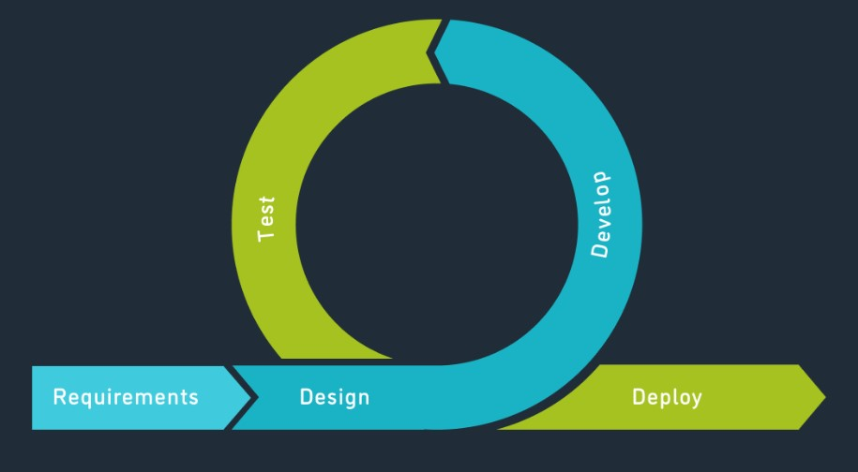

Stages of IDP
Following are the four seminal phases of IPD.
Ideation
Requirement
Analysis
Project Design
Project
Development

Phase 1: Ideation

Ideation is the creative process of generating, developing, and communicating ideas. It’s important to note that these ideas don’t have to be completely new. You can ideate to solve specific problems, look into new ways of implementing a solution, or even collect feedback and evaluate ideas.
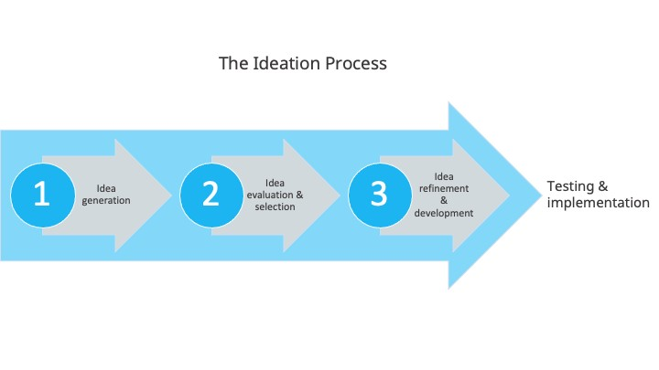

Phase 2: Requirement Analysis

Requirements analysis, also called requirements engineering, is the process of determining user expectations for a new or modified product. These features, called requirements, must be quantifiable, relevant and detailed. In software engineering, such requirements are often called functional specifications.

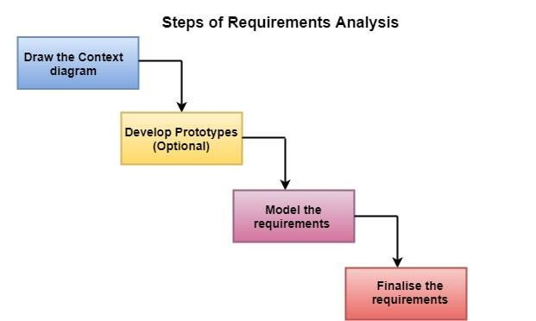

Phase 3: Project Design

Project design is a process to transform user requirements into some suitable form, which helps the programmer in software coding and implementation.

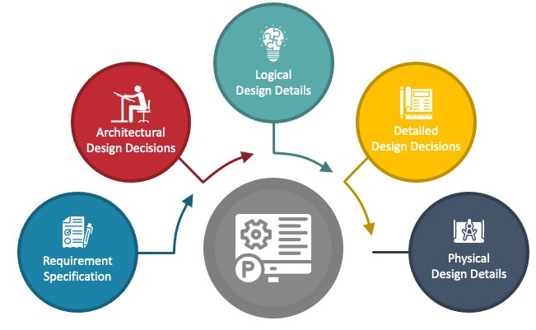

Phase 4: Project Development

Once the system design phase is over, the next phase is development. In this phase, developers start build the entire system by writing code using the chosen programming language. In this phase, tasks are divided into units or modules and assigned to the various developers. It is the longest phase of the Software Development Life Cycle process.

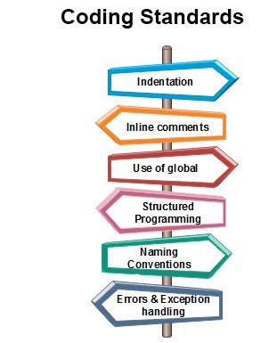
Recommended Program Sequence

The full form of ICP LP name is Integrated Content Platform

The learning journey starts with 5 days of Icebreaker sessions, followed by two stages of technical learning and a Project.
- Stage 1 – Foundation in Software Development - Refresher
- Stage 2 - Application Development and Maintenance Practices
- Integrated Development Project (IDP) – Stage 1 & 2
Stage 1 – Foundational Skills - Refresher

The learning journey contains the courses below, followed by a Stage 1 Assessment.

Stage 1 Assessment

Stage 2- Advanced Programming + IDP

Interim Evaluation (Project + Technical)

Final Evaluation (Project + Technical)

Key Learning and Evaluation Components of the Program

Self-Learning via Udemy
Cognizant has collaborated with Udemy to provide world class learning videos for the evolving future of work. These Udemy programs are woven into a learning path, empowering you to plan and learn at your style.
The program also connects you with Subject Matter Experts (SMEs) to get the professional guidance on your queries in the learning journey.

RAG as PHS (Performance Health Status)
The program continuously evaluates if you are able to apply those self-learnt skills to solve a real-time business problem. Depicted below are the two key evaluation components, which are distributed across the learning journey for the purpose of continuous evaluation.
Interim Evaluation:
During the interim evaluation, the GenC will undergo a video interview on the learning platform. This interview will be conducted by a Tech SME from the BU. The purpose of this evaluation is to assess the GenC's knowledge and understanding of the skills covered in the training program up to the halfway point. It also encompasses an evaluation of the GenC's progress in their Integrated Development Project (IDP). The evaluation will involve a technical discussion as well as an assessment of the IDP progression to gauge the GenC's proficiency in the skills learned thus far.
Final Evaluation:
For the final evaluation, the GenC will participate in a video interview conducted by a Tech SME from the BU. This evaluation aims to assess the GenC's knowledge and expertise in all the skills covered throughout the entire training program. Similar to the interim evaluation, this assessment will involve a technical discussion via a video interview on the learning platform, along with a project evaluation to assess the GenC's capabilities and their IDP's progress. It serves as a comprehensive evaluation of the GenC's skills and capabilities acquired during the training.
Icebreaker



Icebreaker session will be conducted for a duration of initial 5 days. During the session, various topics related to Corporate Induction, Talent Management, Cognizant Agenda on Core Values, Leader Talks, Alumni, BU Mentor connects will be covered. Followed by icebreaker, technical training will kick start.
Following sessions will be covered during the 5 days of icebreaker
- Corporate Induction
- Talent Manager Connect
- Cognizant Agenda Sessions on Core Values
- Leader Talks (Academy) and many more…

Stage 1 - Foundation in Software Development

Overview

Stage 1 deals with foundational technology skills that help GenCs to get start with their software engineering career. We provide unique learning experience to learners by including diversified learning content and learning methodologies that are based on adult learning principles.

As part of Stage 1 of your training, the following skills will be covered.

- Agile
- Devops
- User Interface Design
- SQL Programming
- Java Programming Fundamentals

How and From Where to Learn?

Udemy courses are recommended for learning, and hands-on exercises are organized within a learning path on the Tekstac platform for practice. Additionally, you can utilize other sources mentioned in this handbook for learning.

Agile Methodology

Stage 1: Cour
Day 1

1 - Software Engineering Basics and Agile
What is Agile?

Agile is a set of principles that are used to improve the process of project management and software development. To put in simple terms, Agile helps teams in delivering value to customers quickly and effortlessly.
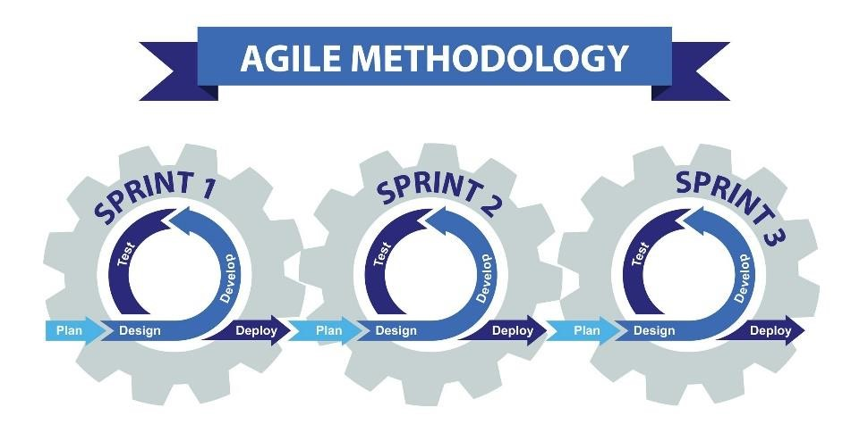

Agile Principles

Here is a sneak peek into some of the principles that help make the Agile Process what it is:
- Customer satisfaction: Customers need to be satisfied with the quick delivery of the product at the earliest.
- Welcome change: Even if the change is late in the development process, it needs to be addressed and handled as soon as possible.
- Deliver frequently: The focus must be on the continuous delivery of software in a shorter timescale.
- Work together: Business units and developers need to work in tandem throughout the project lifespan.
- Motivated team: The projects need to have motivated team members. They must also be trusted to get the work done.
- Face-to-face: Conversations that take place face-to-face have maximum efficiency and effectiveness.
- Working software: The primary measure of progress is evaluated based on the working software created.
- Constant pace: The agile process is greatly beneficial when it comes to sustainable development.
- Good design: Focusing on technological excellence and good design can significantly affect agility.
- Simplicity: The amount of work not being done needs to be reduced via simpler processes.
- Self-organized: Self-organized teams end up providing the best architectures, designs, and requirements.
- Reflection and adjustment: The effectiveness can be significantly improved by regular reflection on it, by the team.
What Are the Advantages of the Agile Process?
- Thanks to agile, there will be plenty of interaction between the project team and the clients.
- The clients can have greater insight into every phase of the project, due to improved transparency.
- The outputs are easily predicted and can sometimes be delivered faster than expected.
- Most projects follow a rigid schedule and can incur predictable costs.
- Agile enables changes that can empower the product catalog to be refined and reprioritized.
- The maximum project value can be ensured since the client can decide the priorities of the features.
- By understanding the needs of the customer, the team can provide more value effortlessly.
- Since the project is broken down into smaller units, development, testing, and collaboration will be of the highest quality.
Learn about Agile process from the below Udemy course.

Agile Crash Course: Agile Project Management; Agile Delivery

- Go through the given sections and implement examples along with the author of this course.

Software Development Life Cycle - Overview

What is SDLC?

SDLC is a process that defines the various stages involved in the development of software for delivering a high-quality product. SDLC stages cover the complete life cycle of a software i.e. from inception to retirement of the product.
Adhering to the SDLC process leads to the development of the software in a systematic and disciplined manner.
Purpose:

Purpose of SDLC is to deliver a high-quality product which is as per the customer’s requirement.
SDLC has defined its phases as, Requirement gathering, Designing, Coding, Testing, and Maintenance. It is important to adhere to the phases to provide the Product in a systematic manner.
For Example, A software has to be developed, and a team is divided to work on a feature of the product and is allowed to work as they want. One of the developers decides to design first whereas the other decides to code first and the other on the documentation part.
This will lead to project failure because of which it is necessary to have a good knowledge and understanding among the team members to deliver an expected product.

SDLC Cycle

SDLC Cycle represents the process of developing software.
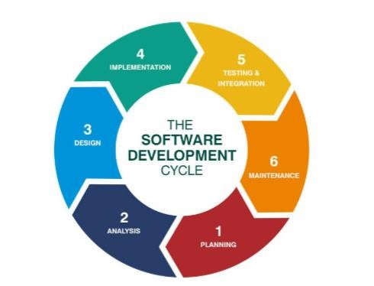

SDLC Phases

Given below are the various phases:

- Requirement gathering and analysis
- Design
- Implementation or coding
- Testing
- Deployment
- Maintenance

#1) Requirement Gathering and Analysis
During this phase, all the relevant information is collected from the customer to develop a product as per their expectation. Any ambiguities must be resolved in this phase only.
Business analyst and Project Manager set up a meeting with the customer to gather all the information like what the customer wants to build, who will be the end-user, what is the purpose of the product. Before building a product a core understanding or knowledge of the product is very important.
For Example, A customer wants to have an application which involves money transactions. In this case, the requirement has to be clear like what kind of transactions will be done, how it will be done, in which currency it will be done, etc.
Once the requirement gathering is done, an analysis is done to check the feasibility of the development of a product. In case of any ambiguity, a call is set up for further discussion.
Once the requirement is clearly understood, the SRS (Software Requirement Specification) document is created. This document should be thoroughly

understood by the developers and should be reviewed by the customer for future reference.
#2) Design
In this phase, the requirement gathered in the SRS document is used as an input and software architecture that is used for implementing system development is derived.
#3) Implementation or Coding
Implementation/Coding starts once the developer gets the Design document. The Software design is translated into source code. All the components of the software are implemented in this phase.
#4) Testing
Testing starts once the coding is complete and the modules are released for testing. In this phase, the developed software is tested thoroughly and any defects found are assigned to developers to get them fixed.
Retesting, regression testing is done until the point at which the software is as per the customer’s expectation. Testers refer SRS document to make sure that the software is as per the customer’s standard.
#5) Deployment
Once the product is tested, it is deployed in the production environment or first UAT (User Acceptance testing) is done depending on the customer expectation.
In the case of UAT, a replica of the production environment is created and the customer along with the developers does the testing. If the customer finds the application as expected, then sign off is provided by the customer to go live.

#6) Maintenance
After the deployment of a product on the production environment, maintenance of the product i.e. if any issue comes up and needs to be fixed or any enhancement is to be done is taken care by the developers.
DevOps & AWS

: Cour
Day 2

Continuous Learning: Technical Enablement


Introduction to Cloud Computing on AWS for Beginners [2025]


Devtools Pro: The Basics of Chrome Developer Tools

- Learn the sections listed below in this Udemy course and complete the corresponding hands-on coding given.
- Implement the examples along with the author.
Milestone 1: UI & Scripting Technologies - Refresher

Overview

Milestone 1 will be focusing on UI & Scripting Technologies such as HTML5, CSS3, JS that are essential while developing a UI in various web application development and maintenance scenarios.

HTML5 is a markup language used for structuring and presenting content on the World Wide Web. It is the fifth and final major HTML version that is a World Wide Web Consortium recommendation. The current specification is known as the HTML Living Standard.

Cascading Style Sheets (CSS) is a style sheet language used for describing the presentation of a document written in a markup language such as HTML or XML. CSS is a cornerstone technology of the World Wide Web, alongside HTML and JavaScript.

JavaScript, often abbreviated as JS, is a programming language that is one of the core technologies of the World Wide Web, alongside HTML and CSS. As of 2022, 98% of websites use JavaScript on the client side for webpage behavior, often incorporating third-party libraries

Performance Outcomes

After completing this milestone, GenC’s will be able to

- Define HTML and common terminology related to HTML, recognize correct HTML syntax, and write a brief error-free HTML code
- Apply style to an existing/new web page as per the requirement using CSS3
- Write and employ JavaScript code to solve practical web design problems

Day 3

HTML5, CSS3

Continuous Learning: Technical Enablement


The HTML & CSS Bootcamp 2026 Edition

Walkthrough the following Udemy course sections and focus on the corresponding topics within our training curriculum's technical scope.
- Ensure that you learn all topics through self -learning and practice alongside the course instructor.

Hands-on

Complete the following set of hands-on given in the Learning Path at Tekstac.
 | Do not copy paste the code. Write the code yourself.

- Newberry Library
- Jasper Sports Academy

HTML5, CSS3

Learn about RWD, Media Queries from the following
- RWD Introduction
- Media Queries

Hands-on

Complete the following set of hands-on given in the Learning Path at Tekstac.

 | Do not copy paste the code. Write the code yourself.

- Calculator
- 4*4 Sudoku
- Whatsapp Chat

Additional Learning

Explore about Chrome Developer Tools from the below given Udemy course


Devtools Pro: The Basics of Chrome Developer Tools

- Go through the given sections and implement examples along with the author of this course

Day 4

JavaScript

Continuous Learning: Technical Enablement

 JavaScript - The Complete Guide (Beginner + Advanced)

- Learn the sections listed below in this Udemy course and complete the corresponding hands-on coding given below.
o Getting Started
o Basics
o Operators
o Control flow
- Implement the examples along with the author.

Hands-On

Complete the following set of hands-on given in the Learning Path at Tekstac.

 | Do not copy paste the code. Write the code yourself.

- Fitness Centre
- Event Reservation Portal
- Display Student Details
- Product Code Validation
- Schedule Upcoming Match
- Counting Game
- SignUp Form validation

Technical Quizzes

Attempt the following technical quizzes in the Learning Path at Tekstac for checking your knowledge level on user interface design.
- Quiz 1 - HTML 5, CSS3
- Quiz 2 - Java Script

JavaScript

Continuous Learning: Technical Enablement


JavaScript - The Complete Guide (Beginner + Advanced)

- Learn the sections listed below in this Udemy course and complete the corresponding hands-on coding given below.
o Control flow
o Objects
Go through W3Schools web pages for learning below specific topics

Form Validation
- JavaScript Form Validation
- JavaScript can validate numeric input
- Data Validation
String Methods
- String Length
- The substring() Method
- String.trim()
JavaScript HTML DOM
- The HTML DOM (Document Object Model)
- What is DOM?
- What is the HTML DOM?
Window alert() Method
- Definition and Usage
- Example
Javascript Arrays
- All topics except Associative Arrays
JSON
- Definition and Usage
- Example
Regular Expression
- Definition and Usage
- Example
isNan() Function
- Definition and Usage
- Example

Practice Case Study

- truYum Case Study
- truYum Web UI Interface Specification

Additional Learning

Go through web pages for learning below specific topics
- HTML5 Events
- HTML5 - Geo location
- HTML5 – Geo location
- HTML5 - Web Storage
- HTML5-Web SQL Database
- WEB Forms 2.0

JavaScript

Additional Learning

 Beginner VS Code

- Go through the below Udemy course in order to learn how to use Visual Studio Code as an Editor for UI development

Note: You can use Visual Studio Code to practice Bootstrap hands-on on local machine

Code Challenges (For Practice Only)

Attempt the following Code Challenges through the Learning Path at Tekstac for checking your skill level on user interface design. The duration of an individual code challenge will be 2hrs and you have to secure 70% in order to clear this challenge.

 | Do not copy paste the code. Write the code yourself.

- Assess- Type -1: Code Challenge - HTML5 and CSS3
- Assess- Type -1: Code Challenge – JavaScript

Course 2: SQL

Overview

Milestone 2 will be focusing on RDBMS and its querying functionality in various application development and maintenance scenarios.

RDBMS stands for Relational DataBase Management Systems. It is basically a program that allows us to create, delete, and update a relational database. Relational Database is a database system that stores and retrieves data in a tabular format organized in the form of rows and columns. It is a smaller subset of DBMS which was designed by E.F Codd in the 1970s. The major DBMS like SQL, My-SQL, ORACLE are all based on the principles of relational DBMS.

Performance Outcomes

After completing this milestone, GenCs will be able to
- Understand the structure and design of relational databases
- Retrieve and manipulate data in MySQL with SQL queries
- Retrieve data from multiple tables using Join and Subquery

ur
Day 5

Learn about ANSI SQL Overview, Introduction to MySQL, Data Definition Language, Data Manipulation Language, Selecting from a Table

Continuous Learning: Technical Enablement

Go through the below topic in order to learn basics of Database.

 Relational Database Design

Learn the sections listed below in the Udemy course and complete the corresponding hands-on coding given below.
- Introduction
- Data Modelling Process
- Database Design
- Second Normal Form
- Third Normal Form
- Design Considerations

Implement the examples along with the author.

Continuous Learning: Technical Enablement


SQL for Beginners: Learn SQL using MySQL and Database Design

- Learn the sections listed below in the Udemy course and complete the corresponding hands-on coding given below.
- Implement the examples along with the author.

Hands-On

Complete the following set of hands-on given in the Learning Path at Tekstac.

 | Do not copy paste the code. Write the code yourself.

- Create Borrowing Table
- Alter Table User
- Alter Table Book
- Remove Table
- Insert User Table
- Update Record
- Delete Record

Additional Learnings

NoSQL Overview

• Introduction to NoSQL

Rank Function

- MySQL RANK Function

Try out the samples found in the above web page.

Stage 1: Cour
Day 6

Learn about JOINS, Aggregate Functions, Subqueries

Continuous Learning: Technical Enablement


SQL for Beginners: Learn SQL using MySQL and Database Design

- Learn the sections listed below in the Udemy course and complete the corresponding hands-on coding given below.

  - Selecting From Multiple Tables
  - Aggregate Functions
  - Subqueries

- Implement the examples along with the author.
.

Hands-On

Complete the following set of hands-on given in the Learning Path at Tekstac.

 | Do not copy paste the code. Write the code yourself.

    - Diverse Selection
    - Email Providers
    - Book Event
    - Upcoming Fair
    - Routine Checks
    - Security Measures
    - May Birthday
    - Age Demographics
    - Author Detail
    - Price Analysis
    - Updated Email
    - Lended Books
    - The Chronicles of Authors and Their Tales
    - Date Format

Learn about Functions in MySQL

Continuous Learning: Technical Enablement


SQL for Beginners: Learn SQL using MySQL and Database Design

- Learn the sections listed below in the Udemy course and complete the corresponding hands-on coding given below.
o Functions
- Implement the examples along with the author.

Hands-On

Complete the following set of hands-on given in the Learning Path at Tekstac.

 | Do not copy paste the code. Write the code yourself.

- Exploring Users' Literary Journeys
- Active Borrowings with User and Book Details
- Same Authors
- User Borrowing Summary
- Maximum Fine Per User
- Top Users
- User Count by Title and Author

Technical Quizzes

Attempt the following technical quizzes in the Learning Path at Tekstac for checking your knowledge level on ANSI SQL.

  - SQL basics with DML and DDL Statements
  - Querying Database - Operators, Aggregate, String, Date Functions

Code Challenges (For Practice Only)

Attempt the following Code Challenges through the Learning Path at Tekstac for checking your skill level on Oracle SQL. The duration of an individual code challenge will be 2hrs and you have to secure 70% in order to clear this challenge.
 | Do not copy paste the code. Write the code yourself.

- Assess- Type -1: Code Challenge - RDBMS Select Statements
- Assess- Type -1: Code Challenge - RDBMS DDL & DML
- Assess- Type -1: Code Challenge – Function, Scalar & Aggregate
- Assess- Type -1: Code Challenge - Functions & SubQueries

Practice Case Study

truYum Case Study

truYum SQL Specification

IDP - High Level Design


Submit your Design Document and Prototype
Course 3: Application Programming – Core Java

Overview

Milestone 3 will be focusing on Application Programming using Java and its practical implementations in various application development and maintenance scenarios.

Performance Outcomes

After completing this milestone, GenCs will be able to
- Read, write, execute, and debug Java applications
- Understand variables and data types
- Code decision and control structures (if, if/else, switch, while, do/while, for) and use
- primitive data types
- Write user-defined methods
- Write and manipulate collections
- Write programs using object-oriented programming techniques including classes, objects,
- inheritance, and polymorphism
- JDBC to access DB and perform basic operation
- Understand and use Java 8/Java 12 features • Understand Java Security aspects, logging, JMS.

Do You Know?
Interesting Facts about Java

- Sun Microsystems created Java. Java was originally called Oak. Oracle now oversees Java after its acquisition of Sun in 2010.
- A general-purpose, high-level programming language.
- Java is the second most popular language after C.
- 95 percent of enterprises use Java for programming.
- Java’s latest major release is the Platform Standard Edition 8.

Stage 1: Cour
Day 7

Overview, First Java Program, Variables, Datatypes, Literals, Operators, Expressions and Conditional Statements.

Continuous Learning: Technical Enablement

 Java Foundations: The Complete Course with Java 21 Updates

    - Learn the sections listed below in the Udemy course and complete the corresponding hands-on coding given below
    - Implement the HelloWorld Program along with the author.

 Java Programming For Beginners | Core Java Using IntelliJ

- Learn the sections listed below in the Udemy course and complete the corresponding hands-on coding given below
- Implement the HelloWorld Program along with the author.

Hands-On

Complete the following set of hands-on given in the Learning Path at Tekstac.

 | Do not copy paste the code. Write the code yourself.

- Streamline Your Health Journey
- Water Tank Capacity
- Square Series
- WordZee
- Fishing competition

Stage 1: Cour
Day 8

Overview, String, Arrays, Looping Statements, Methods, Class, Object, static.

Continuous Learning: Technical Enablement

 Java 21: New Features and Enhancements

- Learn the sections listed below in the Udemy course and complete the corresponding hands-on coding given below
- Implement the HelloWorld Program along with the author.

 Learn JAVA Programming - Beginner to Master

- Learn the sections listed below in the Udemy course and complete the corresponding hands-on coding given below
- Implement the HelloWorld Program along with the author.

Hands-On

Complete the following set of hands-on given in the Learning Path at Tekstac.

 | Do not copy paste the code. Write the code yourself.

- Booking System
- Streamline Your Health Journey
- Water Tank Capacity
- Square Series
- Automate Sum Finder
- Number Crunch Challenge
- Middle Number Game
- WordZee

Access Modifiers, Packages, Inheritance, Abstraction.

Continuous Learning: Technical Enablement

 Java Masterclass 2025: 130+ Hours of Expert Lessons

- Learn the sections listed below in this Udemy course and complete the corresponding hands-on coding given below.
- Implement the examples along with the author.

Hands-On

Complete the following set of hands-on given in the Learning Path at Tekstac.

 | Do not copy paste the code. Write the code yourself.
- Fishing competition
- Brilliant Restaurant
- Dazzle Closet
- Mass Of Rocket Component
- Lego Builders
- Plan Smart
- Mythic Rhythms

Technical Quizzes

Attempt the following technical quizzes in the Learning Path at Tekstac for checking your knowledge level on Java.

- Java Operator, Control flow statement
- Applying Object Oriented Concepts in java

Additional Learning

JMS: JMS Basics

Decompiling Classes in Java

Serial and Parallel Sorts in Java
- Serial and Parallel Sorts in Java

Streams and Optionals

- Java Steams
- Java Optionals

e 1:
Polymorphism, Encapsulation, Interface, Object Methods.

Continuous Learning: Technical Enablement

 Mastering Java Reactive Programming [ From Scratch ]

- Learn the sections listed below in this Udemy course and complete the corresponding hands-on coding given below.
- Implement the examples along with the author.

Hands-On

Complete the following set of hands-on given in the Learning Path at Tekstac.

 | Do not copy paste the code. Write the code yourself.
    - Fitness Tracker
    - Mystic Line
    - Area And Volume
    - The Perfect Password
    - Array Aggregate
    - Product Details

e 1:
Polymorphism, Encapsulation, Interface, Object Methods.

Additional Continuous Learning: Technical Enablement

 Core Java Made Easy (Covers the latest Java 18)

- Learn the sections listed below in this Udemy course and complete the corresponding hands-on coding given below.
- Implement the examples along with the author.

Hands-On

Complete the following set of hands-on given in the Learning Path at Tekstac.

 | Do not copy paste the code. Write the code yourself.

- Parse the Dates
- Babitha’s App
- Investment Calculation
- Customer Record
- College Namelist
- Library Management

Additional Learning

Logging : Introduction to Logging
Log4J : Log4J overview

Collection Framework, ArrayList, Map, Set.

Continuous Learning: Technical Enablement


Java Database Connection: JDBC and MySQL

- Learn the sections listed below in this Udemy course and complete the corresponding hands-on coding given below.
- Implement the examples along with the author.

Hands-On

Complete the following set of hands-on given in the Learning Path at Tekstac.

 | Do not copy paste the code. Write the code yourself.
- Alta Motors
- Concept And Implementation
- Student Score Info
- Vintage Books Emporium
- Animalia
- Copy Names
- Fit Freak
- Employee Details

Introduction, Connection, Statement, Prepared Statement, Callable Statement, Transactions and Meta Data.

Continuous Learning: Technical Enablement


Java Database Connection: JDBC and MySQL

- Go through entire course.
- Implement the examples along with the author.

Technical Quizzes

Attempt the following technical quizzes in the Learning Path at Tekstac for checking your knowledge level on Java.

- Collections Framework
- Advanced Java Concepts

Code Challenges (For Practice Only)

Attempt the following Code Challenges through the Learning Path at Tekstac for checking your skill level on Java, JDBC. The duration of an individual code challenge will be 2hrs and you have to secure 70% in order to clear this challenge.

 | Do not copy paste the code. Write the code yourself.

- Assess-Type-1: Code Challenge – Java - Group1
- Assess-Type-1: Code Challenge – Java - Group2

Practice Section

e 1: Co
Take the Practice session questions to become familiar with the assessment platform and the format of the questions used in the Stage 1 Assessment. Ensure you submit your solutions and check their correctness against the test cases

U

Continuous Learning: Technical Enablement


Java Masterclass 2025: 130+ Hours of Expert Lessons

- Go through entire course.
- Implement the examples along with the author.

Integrated Capability Test (ICT) (For Practice Only)

Attempt the following Integrated Capability Test (ICT) through the Learning Path at Tekstac for checking your skill level on Stage 1 skills majorly database and application programming skills. The duration of the ICT will be 4 hrs. and you have to secure 70% in order to clear this practice test.
 | Do not copy paste the code. Write the code yourself.

- Java Assess-Type-2: Integrated Capability Test (ICT)

Mock Assessment

e 1: Co
Take the mock assessment to become familiar with the assessment platform and the format of the questions used in the Stage 1 Assessment. Ensure you submit your solutions and check their correctness against the test cases

Day 9 -15

CCM Learnings

Stage | Course Segment | Course/Module
1 | Introduction to CCM | What is CCM. Applications and Business Use Cases.
 |  | CCM tools and Architecture.
 |  | CCM Essentials and Basics
2 | Qudient Inspire Designer | Introduction to Inspire Designer and Installation
 |  | Data Input Modules (XML Data Input, JSON Data Input, Data Input, Internal Data Input and Param Input)
 |  | Exercises on Data Input Modules
 |  | Data Processing Modules (Merger Modules, Data Transformer)
 |  | Exercise covering operations in Data Transformer. Data manipulation Exercises.
 |  | Design and Layout (Includes Creating and working with Styles, Static and Dynamic Tables, Images, Types of flows, Page setup and Overflow)
 |  | Exercise on creating styles, tables, repeated flows and overflow scenarios
 |  | Impositioning and Output Modules.
 |  | Exercises on Data Input Modules
 |  | Best practices to be followed.
 |  | End Exercise to generate a output based on the requirement
3 | Quadient Inspire Interactive | Introduction to Interactive and Business Application.
 |  | Concept of Master Template, Data Master, Resource Master, Template, and Blocks.
 |  | Exercise on Creating Master Template, Linking with Data Master and Resource Master.
 |  | Template editor in Interactive.
 |  | Exercise on working in Interactive Template
4 | CLearn | Designer E- Learning Course
 |  | Designer Assessment
 |  | Interactive E-Learning Course
 |  | Interactive Assesment
5 | BU Final Exercise Evaluation | Designer Certification Exercise and Interacitve Exercise Certification

Stage 1 – Assessment – NO Assessment

Stage 1 Assessment

- These days will be dedicated for the Assessment and Result Publishing

IDP – Project Activities

Day 16,17

IDP – Project Design

- These days will be spent on IDP - Project Design work

Stage 2 – Frameworks and Tools

Overview

Stage 2 deals with application frameworks and tools that are seminal while developing/maintaining various software applications. We provide unique learning experience to learners by including diversified learning content and learning methodologies that are based on adult learning principles.

As part of Stage 2 of your training, the following skills will be covered.

- IoC and Dependency Injection Framework
- TDD, Junit, Code Quality
- MVC Framework

How and From Where to Learn?

- Udemy learnings are recommended in the Platform to understand the fundamental concepts. In addition to this, you can also learn from any other sources as they are mentioned in this handbook.
Integrated Development Project (IDP) Roadmap

Phases | Activities | Deliverables
Development | Sprint 1 Development & Review | DAO
 | Sprint 2 Development & Review | Completed project’s code base

Milestone 1 – IoC and Dependency Injection Framework

Overview

Milestone 1 will be focusing on IoC and Dependency Injection Framework.

Spring is an open-source lightweight framework that allows Java EE 7 developers to build simple, reliable, and scalable enterprise applications. This framework mainly focuses on providing various ways to help you manage your business objects. It made the development of Web applications much easier than compared to classic Java frameworks and Application Programming Interfaces (APIs), such as Java database connectivity (JDBC), JavaServer Pages(JSP), and Java Servlet.
Dependency injection is a pattern we can use to implement IoC, where the control being inverted is setting an object's dependencies.

Performance Outcomes

After completing this milestone, GenCs will be able to
- Create and manage a simple application using Maven
- Apply Dependency Injection Scenario using Spring Core.
- Use Spring JDBC and Transactions for a simple scenario.

GenAI Code Assist Tools

Program Overview:

The learning plan comprises self-paced modules along with an expert-led session covering GenAI Foundation, Prompt Engineering, and GitHub Copilot.

It also includes hands-on implementation and case study exercises for GitHub Copilot, with licenses provided to participants. The overall approach blends guided learning with practical applications

Day 18

Maven & Spring Core

Needs and benefits, Maven Project Creation, POM.xml, Build lifecycle, repositories, Scopes and Profiles.

Continuous Learning: Technical Enablement


Spring Framework in Easy Steps
- Go through the below mentioned sections and implement examples along with the author of this course.
- Introduction
- Software Setup
- Troubleshooting Maven Projects o Setter Injection
- Create a Maven Project
- Create the Java Bean
- Create the Spring Configuration
- Create and run the test
- Value as attribute

Hands-On

Complete the following set of hands-on given in the Learning Path at Tekstac.
 | Do not copy paste the code. Write the code yourself.

- Display Staff Details
- Display Book Details – Autowiring
- Gold Rate Calculation – Collections
- DBConfig-SetterBasedInjection

Injecting collections, dependency check, Inner Beans and Scope.

Day 19

Maven & Spring Core

Continuous Learning: Technical Enablement

Spring Framework in Easy Steps
- Go through the below mentioned sections and implement examples along
with the author of this course.

  - Setter Injection
  - Injecting Collection
  - List - Create the Spring Bean List
  - Create the Configuration file
  - List - Create the Test
  - Running the test and flow
  - Two More Things About List
  - Dependency Check, Inner beans and Scopes

Hands-On

Complete the following set of hands-on given in the Learning Path at Tekstac.

 | Do not copy paste the code. Write the code yourself.

- DBConfig-SetterBasedInjection
- Smart Home Lighting System
- SpringAopDemo
- Loan Pro

Constructor based Injection, Auto wiring, Usage of Properties

Gen AI Foundation

Fundamentals of Generative AI [101-Basics] (Activity Code: ELRNG01863)

This AI course is designed to equip learners with:

- The foundational knowledge and skills required to harness the power of G enerative AI.
- The ability to identify opportunities for innovation and implementation of AI within their organizations.
- The skills to drive organizations toward a future of enhanced creativity and competitive advantage using AI techniques.

Day 20

Maven & Spring Core

Continuous Learning: Technical Enablement


Maven Crash Course
  - Learn the sections listed below in this Udemy course and complete the corresponding hands-on coding given below.
- Introduction
- Maven Project Creation and Key Concepts
- Scopes o Profiles Spring Core - Setter Based Injection.
Additional Hands-On

Complete the following set of hands-on given in the Learning Path at Tekstac.

 | Do not copy paste the code. Write the code yourself.

- EBill
- Shipment-Item-Scope
- Billing Software Application
- Azure Horizon Resort
- PatientManagement
- Hospital Management
- Account-Loan

Day 21
,
Maven & Spring Core

Continuous Learning: Technical Enablement


Maven Crash Course
  - Learn the sections listed below in this Udemy course and complete the corresponding hands-on coding given below.
- Introduction
- Maven Project Creation and Key Concepts.

Hands-On

Complete the following set of hands-on given in the Learning Path at Tekstac.

 | Do not copy paste the code. Write the code yourself.

- Build Web Application
- Compiling Executing Java using POM
- Junit With Maven
- Maven Directory Structure
- Maven Shade Plugin
- Maven App to access External Service
- Capital Service

Gen AI Foundation

Introduction to Responsible AI (Activity code: CGZ-914en)

This AI course is designed to equip learners with Overview of Responsible AI principles.

Code Challenges (For Practice Only)

Attempt the following Code Challenge through the Learning Path at Tekstac for checking your skill level on Spring Core. The duration of an individual code challenge will be 1hr and you have to secure 70% in order to clear this challenge.

 | Do not copy paste the code. Write the code yourself.

• Assess-Type -1: Code Challenge - Spring Framework

Gen AI Foundation

Responsible AI-Deep Dive [101- BASICS] (Activity code: ELRNG02344)

This AI course is designed to equip learners with Fairness, Accountability, Safety,
Transparency

Milestone 2 – Unit Testing, Code Quality

Overview

Milestone 2 will be focusing on Unit Testing frameworks such as JUnit, Code Quality aspects and their implementation during Test Driven Development.

Unit Testing is a software testing method by which individual units of source code—sets of one or more computer program modules together with associated control data, usage procedures, and operating procedures—are tested to determine whether they are fit for use.

JUnit is a unit testing framework for Java programming language. JUnit has been important in the development of test-driven development. TDD is one of those practices which contribute to better code quality and decreases bugs.

Code Quality - The code quality is important, as it impacts the overall software quality. And quality impacts how safe, secure, and reliable your codebase is. Developers can improve the Java code quality by simply applying best practices and using the right analysis tools.

Performance Outcomes

After completing this milestone, GenCs will be able to
- Understand the fundamentals concepts of test-driven development
- Perform Unit Testing using the JUnit Framework

Day 22,23

Continuous Learning: Technical Enablement

Writing basic tests, Assert Statements, Testing Exceptions, Comparing Arrays, Parameterized Tests, Test Suites.

Learn and Practice


Instant Test Driven Development with Java, JUnit and Mockito
Introduction Unit Testing with Junit

- Step 1: Why is Unit Testing Important?
- Step 2: Setting up your first Junit.
- Step 3: First Successful JUnit.
- Step 4: Refactoring Your First Junit Test
- Step 5: Second JUnit Example assertTrue and assertFalse
- Step 6: @Before @After
- Step 7: @BeforeClass @AfterClass
- Step 8: Comparing Arrays in Junit Tests
- Step 9: Testing Exceptions in Junit Tests
- Step 10: Testing Performance in Junit Tests
- Step 11: Parameterized Tests
- Step 12: Organize JUnits into Suites

Hands-On

Complete the following set of hands-on given in the Learning Path at Tekstac.

 | Do not copy paste the code. Write the code yourself.

- EB Connection
- CarcoExpress
- Employee Details
- Employee Appraisal
- Employee Address Update

AI Learnings - Flowsource

Cognizant Flowsource 101 foundation program [101-BASICS](Activity Code: ELRNG02089)

By the end of this elearning, you will be able to:
- Flowsource technology and how it transforms the business operations
- Flowsource and its relevancy in today's world
- Complete view of Flowsource lifecycle
- Future model of Application Development and future value stream using Flowsource

Day 24,25

Continuous Learning: Technical Enablement

The concepts include importance of code quality and coding standards.

PMD

- Introduction to PMD
- PMD Rules
- PMD Reports
- Rules Customization and Suppression

Hands-On

Complete the following set of hands-on given in the Learning Path at Tekstac.

 | Do not copy paste the code. Write the code yourself.

- Computation Service
- Employee Details
- Crisp Placement Training
- Book A cab
- Mobile Sales Application

Checkstyle

- Introduction to Checkstyle
- Checkstyle Rules
- Checkstyle Reports
- IDE Integrations

SonarQube

- Introduction of SonorQube
- SonarQube Metrics and Rules
- SonorQube Reports
- IDE Integration

SpotBugs

- Introduction SpotBugs
- SpotBugs Analysis
- SpotBugs Reports
- IDE Integration

JaCoCo

- Introduction to JaCoCo
- JaCoCo Reports

AI Knowledge check

GENERATIVE AI QUICK ASSESSMENT FOR ELEARNING QUIZ [101-BASICS]

- This assessment is to assess the knowledge of associates on Generative AI tools and concepts at a Beginner proficiency.

IDP – Project Activities

–
Day 26 to 29

IDP – Development & Review

• These four days will be spent on project development activities

Milestone 3 – MVC Framework

Overview

Milestone 3 will be focusing on Spring MVC with Spring Boot.

Spring MVC with Spring Boot is widely used framework to create scalable web applications. With Spring Boot, you’ll be able to develop Spring applications with more agility and be able to focus on addressing your application’s functionality needs with minimal. You can easily create a selfcontained HTTP server using embedded Tomcat, Jetty, or Undertow. Most web applications will use the spring-boot-starter-web module to get up and running quickly. Spring Boot provides auto-configuration for Spring MVC.

Performance Outcomes

After completing this milestone, GenCs will be able to
- Initialize a Spring Boot Project and work with an existing project.
- Able to use simple MVC components for coding the presentation layer of a module using Spring MVC.

Day 30

Spring Boot, Spring MVC

Overview, Understanding Servlets, Web Application Request Flow

Continuous Learning: Technical Enablement


Spring Boot 4, Spring 7 & Hibernate for Beginners

- Go through the below mentioned sections and implement examples along with the author of this course.

Hands-On

Complete the following set of hands-on given in the Learning Path at Tekstac.
 | Do not copy paste the code. Write the code yourself.

- SwiftCartPortal
- Top Colleges List
- Sports Academy
- SignUp Form

Prompt Engineering:

Prompt Engineering Foundation - PY0009562

This AI course is designed to equip learners with Prompting techniques, best practices, ethics, hands-on lab

Day 31

Continuous Learning: Technical Enablement

View Resolver, @RequestParam, ModelMap,Dispatcher Servlet, Spring MVC Web request flow, Web Application Architecture, Session scope, Request scope,@SessionAttributes.

Learn and Practice


Spring Boot 4, Spring 7 & Hibernate for Beginners
Go through the below mentioned sections and implement examples along
with the author of this course.

Hands-On

Complete the following set of hands-on given in the Learning Path at Tekstac.

 | Do not copy paste the code. Write the code yourself.

      - Dexler Preschool
      - PulsePursuit Tournament

GitHub Copilot:

Introduction to GitHub Copilot

This course is designed to equip learners with Overview of GitHub Copilot features

Day 32,33

JSTL tags, Spring MVC form tag library, Validations, initBinder

Continuous Learning: Technical Enablement


Reactive Programming with Spring Framework 5

Go through the below mentioned sections and implement examples along
with the author of this course.

Additional Learning

Spring MVC Internationalization (i18n) - implement internationalization using the Spring MVC framework. Learn the additional topics as mentioned below.

- Refer this document and implement the example.
- Introduction to Tomcat
- Tomcat servlet interactions
- Application Server Vs Web Server
- MVC Frameworks Overview
- Spring MVC Architecture | Coding Shuttle

Technical Quizzes

Attempt the following technical quizzes in the Learning Path at Tekstac for checking your knowledge level on user interface design.

- Spring Boot, Spring MVC

Code Challenges (For Practice Only)

Attempt the following Code Challenge through the Learning Path at Tekstac for checking your skill level on Spring MVC with Spring Boot. The duration of an individual code challenge will be 2hr and you have to secure 70% in order to clear this challenge.
 | Do not copy paste the code. Write the code yourself.

- Assess-Type -1: Code Challenge - Spring MVC with Spring Boot

GitHub Copilot:

GitHub Copilot for Beginners: AI Coding Crash Course

This course is designed to equip learners with Beginner-friendly coding with Copilot

GitHub Copilot – The Complete Guide – 2025

This course is designed to equip learners with Comprehensive guide to Copilot usage

Interim Evaluation

Day 34, 35
46

Interim Project Evaluation & Interim Technical Evaluation

• Interim evaluation will be conducted during these days

- Timing: Mid of Stage 2
- Focus Areas: Stage 1 skills and Stage 2 skills
  - Technical: Foundational skills, agile practices, Spring Core Maven, TDD, Junit and Code Quality, Spring MVC with Spring Boot
  - Project: Hands-on completion, collaboration, initial project setup
- Format: One-on-one Technical and Project review
- Attempt: 1
- Outcome: RAG (Red-Amber-Green) grading
- Green: On track and progressing well
- Amber: Needs improvement in specific areas
- Red: Significant gaps in understanding or delivery

Milestone 3 – Python

Day 36,37
46
Python

Continuous Learning: Technical Enablement

Complete Python Programming Masterclass Beginner to Advanced

- Go through the given sections and implement examples along with the author of this course.

Hands-On

Complete the following set of hands-on given in the Learning Path at Tekstac.
 | Do not copy paste the code. Write the code yourself.

- Welcome Message
- Virtual Assistant
- Hospital Billing
- Stationary Shop
- Theme Park Pricing
- Cash Exchange
- House Rent Calculator
- Airline Reservation System
- Voting System
- Fitness Tracker Analyzer
- Non-Working Doctors
- Product Sales
- Participant Registration and Preference Analysis
- Student Electives
- Sort the Student Details Dictionary
- Online Shopping Cart System
- Pattern Generator

Day 38,39
46

Python

Continuous Learning: Technical Enablement

Complete Python Programming Masterclass Beginner to Advanced

- Go through the given sections and implement examples along with the author of this course.

Hands-On

Complete the following set of hands-on given in the Learning Path at Tekstac.
 | Do not copy paste the code. Write the code yourself.

- Basket Ball Player Analysis
- Percentage of marks - Lamda Functions
- Data Encryption
- Vehicle Premium
- Classic Curve Members
- Area calculation - Method Overrding
- Tournament - Method overloading
- Complex Addition
- Generate Customer Id
- Employee Appraisal
- Product Information
- Filter the Countries Sachin has Played Against - CSV file
- Filter Customers - JSON File
- Password Update
- Lucky Number - Generator
- Project Allocation - Iterator
- Summer Camp - Decorator

Technical Quizzes

Attempt the following technical quizzes in the Learning Path at Tekstac for checking your knowledge level on user interface design.

- Python

Code Challenges (For Practice Only)

Attempt the following Code Challenge through the Learning Path at Tekstac for checking your skill level on Spring MVC with Spring Boot. The duration of an individual code challenge will be 2hr and you have to secure 70% in order to clear this challenge.

 | Do not copy paste the code. Write the code yourself.

- Assess-Type-1: Code Challenge - Python
Mandatory Learning

Day 40,41
46
MongoDB

Continuous Learning: Technical Enablement

Introduction to the MongoDB

- Go through the given sections and implement examples along with the author of this course

Hands-On

Complete the following set of hands-on given in the Learning Path at Tekstac.
 | Do not copy paste the code. Write the code yourself.

- Updating Book Documents
- Update Many Employees
- Changes made based on publisher
- Remove Fields
- Delete an Employee
- Count Based On Job
- Add an Employee into Collection
- Add Training Information
- Delete collection
- Category Based On Size
- Embedded Document
- Employees Details Based On Hired Year
- Female Employees Details
- Employees Monthly Salary
- Employee Salary Details
- Hindi and English Books
- Create a Unique Index
- Create a Composite Index
- Index Info
- Display all indexes
- Debugging - Aggregate 1
- Debugging - Aggregate 2
- Debugging - Add
- Debugging - Update
- Education Levels
- Analyst Details
- Employee Details
- Employee Information
- Total Salary
- Books Based On Publication
- Book Details Based On Condition
- Email Count
- Price Reduction
- User Defined Index
- Overall Price
- Salary Update
- Titles With Authors
- Password Generation
- Publication Year
- Employee Info
- Author Signature
- Clerk And Salesrep Salary Details
- Author Info
- Publisher-Specific Book Counts
- Map Reduce Employees
- Map Reduce Book
- Text Search

Day 42,43
46
Microservices

Learn and Practice


Master Microservices with Spring Boot and Spring Cloud

- Go through the given sections and implement examples along with the author of this course

Day 44
46
Containerization

Learn and Practice

Docker for the Absolute Beginner - Hands On - DevOps

- Go through the given sections and implement examples along with the author of this course

IDP – Project Activities

Day 45 - 48
46

IDP – Development & Review

• These days will be spent on project development activities for next Sprint.
Inspired Learnings

Day 49 - 52

Inspired Learnings

Inspire Interactive

- Quadient Inspire Interactive [101-BASICS]

Inspire Scaler

- Basics of Inspire Scaler [101 Ã¢â‚¬â€œ Basics]

- Quadient Inspire KBA [101 - Basics]

Mandatory Learning

Day 53 to 55

Scala

Learn and Practice


Apache Spark Programming in Scala for Beginners (2026)

- Go through the given sections and implement examples along with the author of this course

Flask

Learn and Practice


REST APIs with Flask and Python in 2025

- Go through the given sections and implement examples along with the author of this course

Day 56

Neo4J

Learn and Practice


Neo4j: GraphDB Foundations with Cypher

- Go through the given sections and implement examples along with the author of this course

Final Evaluation

Day 57 to 59

Final Project Evaluation & Final Technical Evaluation

• Final evaluation will be conducted on these days

- Timing: End of Stage 2
- Focus Areas: All skills from Stage 1 to Stage 2
  - Technical: Foundational, Python, Microservices, Mongo DB, Containerization, Sitecore
  - Project: Capstone project delivery, architecture, implementation, testing, deployment (local)
- Format: One-on-one technical interview and project walkthrough
- Attempt: 2
- Outcome: RAG grading
- Green status is expected for successful completion

How to learn Each Day?

Each day has a set of learning objectives. These learning objectives can be met by going through the Udemy courses and by completing the hands-on exercises mentioned in the daily plan.

The below strategies will help you decide the learning approach.

Learning Strategy & Approach

Find below few imaginary profiles. For each of these profiles we have defined a recommended learning approach. This is not an exhaustive list. The approaches below might help invent a new way of learning.

Profile #1

Harry Reacher
Engineering Discipline: Electronics
Skills: Python, Ruby on Rails, nginx
Project: Mining Crime Data to get Route Cause Insights
Learning Approach to Programming Languages: I do not want to waste my time learning. I am more practice oriented. I want to work on the problem immediately
What will work for me?
- Directly complete hands-on exercises
- Refer Internet or Udemy Courses
- If hands on are implemented early, clarify your friends’ questions and troubleshoot their issues

Profile #2

Olivia Richards
Engineering Discipline: Computer Science
Skills: Java, C, C++
Project: Library Management System
Learning Approach to Programming Languages: I have interest, but I don’t know where to start.

What will work for me?
- Go through the recommended Udemy Course
- Try completing the hands-on exercises
- Get your clarifications solved with help from Tech SME
- Get help from other learners in your batch whom had already completed

Profile #3

Greg Anderson
Engineering Discipline: Civil
Skills: C
Project: Fiber reinforced concrete
Learning Approach to Programming Languages: I am scared of programming languages. I haven’t got my hands dirty with coding
What will work for me?

- Go through the recommended Udemy Course
- Implement the coding along with the author of the Udemy Course
- Try completing the hands-on exercises
- Clarify queries with SME
- Troubleshoot programming issues with help from SME or learner from your classroom whom had already completed

FAQs

- Who can participate in this program?
Ans: Students who have enrolled for Full Internship Program (or) the Cognizant on-boarded GenCs can participate in this program.
- Is there any pre-learning I should do?
Ans: No. This program is open to all students from any academic discipline.
- What is Code Challenge?

Ans: A problem statement will be provided to you and you need to solve it using a single skill.

- What is Integrated Capability Test (ICT)?

Ans: A case study problem statement will be provided to you that you may need to solve using the combination of skills learned in the given stage.

- How many attempts are provided for the Coding challenge and ICTs? Is it open all the time for practice?

Ans: The coding challenges and ICTs are open from day 1, and a maximum of 3 attempts will be provided.

- What if I fail in the Interim evaluation?
Ans: Your coach will notify your performance in the Interim evaluation. However, you can continue with the learning.

- How many chances will I get in the Final evaluation?

Ans: You’ll get 2 chances in the Final evaluation which covers ALL the skills in the learning journey.

- Will we be provided with Projects to work on?

Ans: No, you will have to ideate, design and develop the project which will be reviewed and assessed by the project mentor.

- Whom do I reach out in case of any queries?
Ans: Coach is your point of contact.

